Design documents (Draft)

This section contains the design models for the clerk at SuperRent Car Rental Company.

# System Design

The design of the overall clerk system structure.

## Architecture

At the architectural design level, we use an architectural context diagram (ACD) to model the manner which software interacts with entities external to its boundaries.

Superordinate systems – the Clerk function is one component of SuperRent system. It will call by up level functions

* Subordinate systems - ???
* Peer-level systems – Report Display, Credit Card Validation, Car rental system
* Actors - Clear, Control Panel, Menu Display

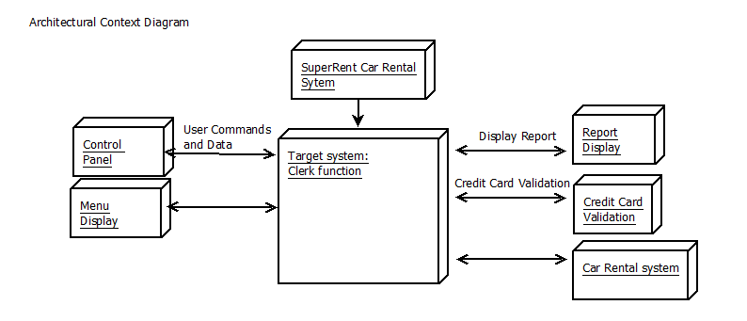

## Components

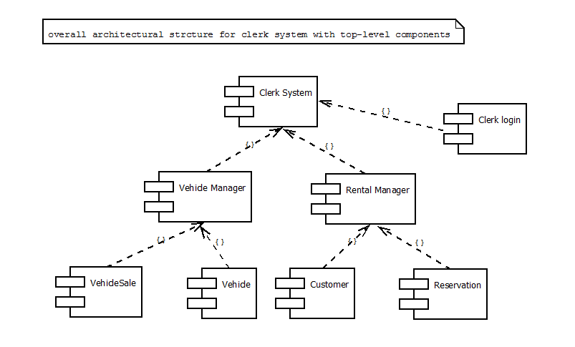

## Database / data structure

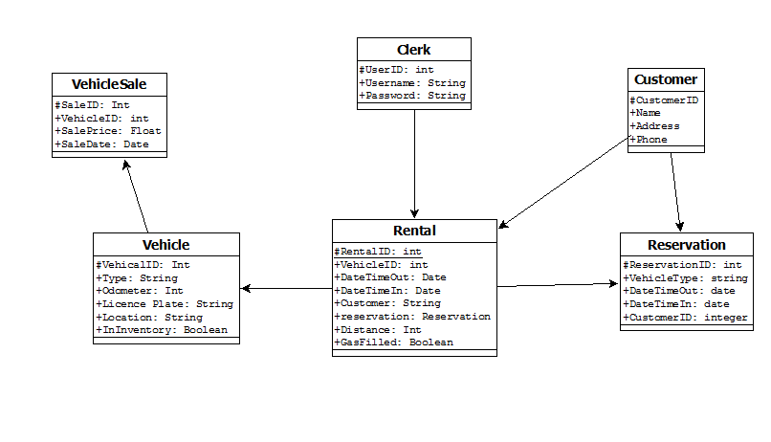

## Detailed Class Diagrams

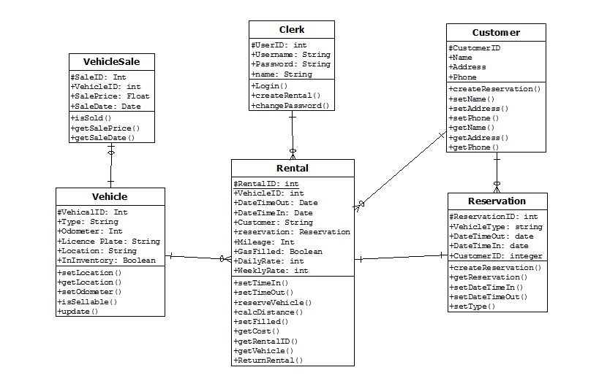

# Detailed Sequence Diagrams / State Diagrams

## Login

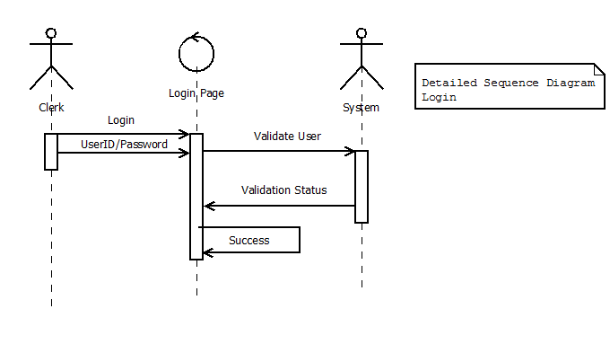

## Create Rental

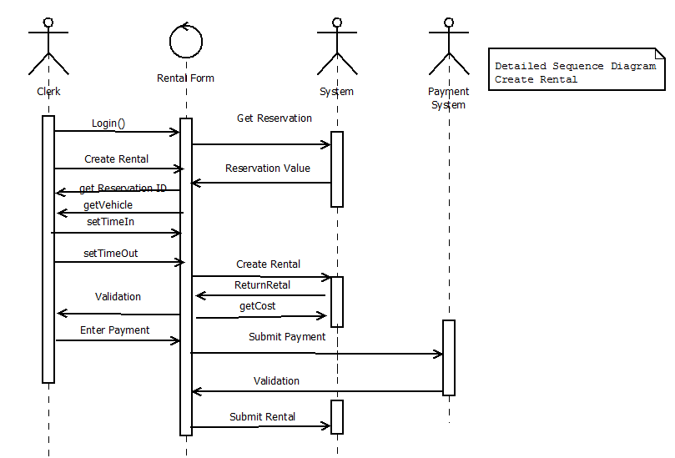

## Show Report

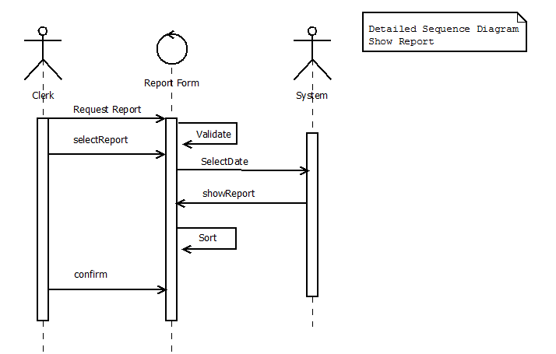

## Return Vehicle

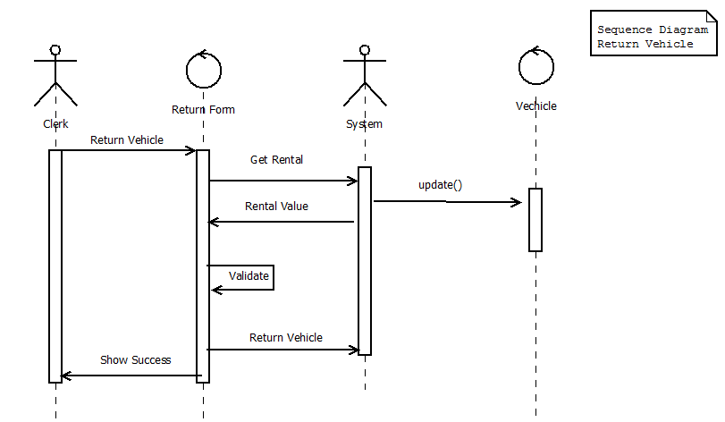

# User Interface (Not sure if we are going to use a web, if no just change following web related to client/server)

* Common theme Design, each section of the site should have a common look/theme. The company logo should be on every page as well as a common header. All font types and basic layout should be used throughout the site
* Graphic files should be relative to site. Design with simplicity to allow for quickest loading. All pages should be tested at both 28K and 56K dial-up modem speeds to ensure each webpage can be accessed timely.
* Designed for HTML version 5.0, version of browser MS Internet Explorer 6.0+ and compliable browsers.
* Filename convention: file extensions = “.html”, home page name =”index.html”
* Scripting languages: PHP 5.0 ???
* Database: MS-ACCESS
* SSL for secure information transferring over internet, such as credit card information, password.

## Style Guide

Visually appealing - The site must have attractive mix of text, photos and graphics and should give customers a strong impression of the hotel service, features and characteristics.

Theme of the site - warm tones, giving the feeling of home, highlights, simple and clear language, images reflect the theme of the site, and showing the site's personality and taste. Promotion and corporate logo will through the site to enhance their visibility.

For ease of use, the website must provide consistent orientation and navigational aids, such as hierarchical menus that tell users how deep they are into a topic or subtopic as well as a homepage link or icon on each page in the same position.

### Screen page

* Page header: identification of the web site and its logo.
* Page: navigation should be the major part, the online room booking, special offers, partners’ information, membership information, and the latest event information.

### Navigation design

Navigation system is an effective tool to connect pages through hypertext or image links, the viewer can easily open pages on the website.

## Screen Layout

This is a sample of layout. All pages of the site will follow, and each page will has it own contents as style guide.

## Screen Template

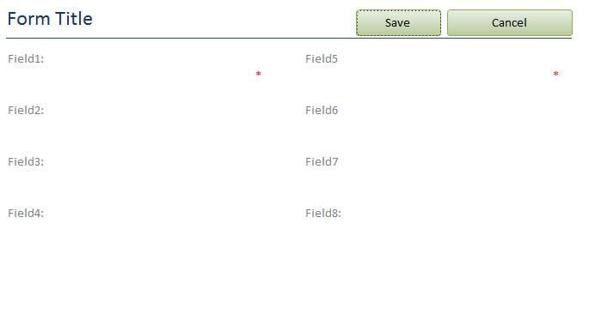

## Vehicle Sale Screen

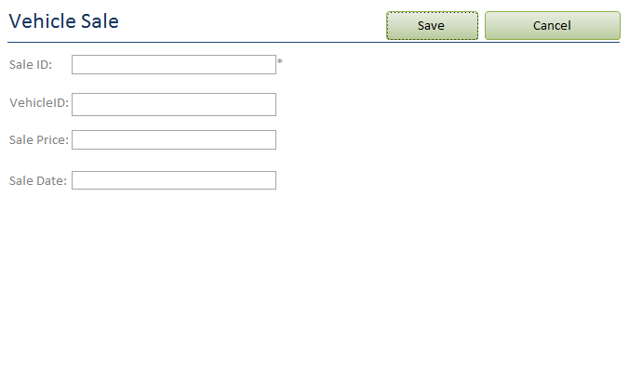

## Clerk Login screen

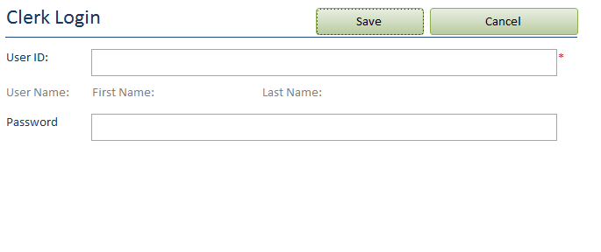

## Vehicle screen

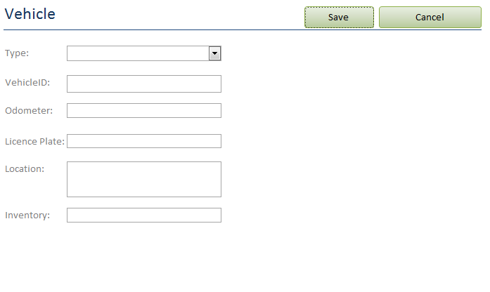

## Rental Screen

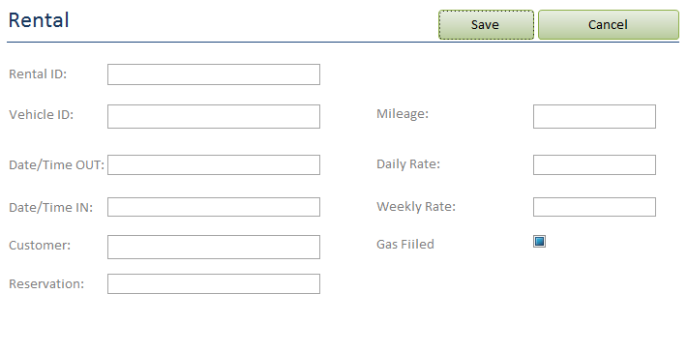

## Customer Screen

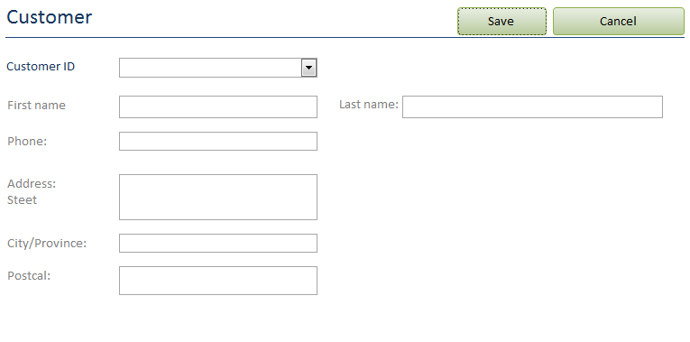

## Reservation Screen

